PEDAGOGICAL KNOWLEDGE, SKILLS, AND DISPOSITIONS
To be completed by the classroom teacher (field experience) and course instructor. Both must recommend the continuance of the student in the teacher prep program, sign, and date the form. Students receiving ratings of 1 must meet with the instructor and develop a plan for improvement. Students must also sign the disposition.
Student Evaluation for Methods Courses

STUDENT NAME ______________________________ PROFESSOR NAME _____________________________ COURSE __________________
TERM ________ YEAR ________ School/Subject Area(s) ________________________________________ Grade Level ________

MENTOR TEACHER NAME _________________________________________ Rating: 1 = Needs Improvement NR = Not Observed/Rated
2 = Satisfactory
DOMAINS OF MODEL OF TEACHER EDUCATION | TARGET INDICATORS | Mentor  Teacher  rating | Professor  rating | COMMENTS
Integration of Faith and Learning | The teacher candidate demonstrates that the integration of Faith and Learning enhances the development of a professionally empowered  educator who exhibits the principles of caring for and service to mankind with Christ as the model in personal and professional situations.
Content Knowledge | The teacher candidate demonstrates competence and confidence in knowledge of the content that encompasses the theories, principles, and concepts of a particular discipline. This includes deep knowledge of the subject itself as well as an understanding of how that content is integrated and best taught across the curriculum and supportive to the specific standards of the discipline being taught.
Management and  Organization | The teacher candidate demonstrates the understanding of planning and teaching procedures and routines to maximize instructional time, proactively managing the learning environment, and using strategies that keep students actively engaged without interruptions or behavioral problems. Throughout the coursework and field experience the candidate develops reasonable rules and procedures, effectively manages the physical and behavioral environment to facilitate instruction, organizes time, materials, and equipment to positively affect academic performance, and utilizes strategies and skills that motivate learners and keep them on task.
Pedagogy | The teacher candidate demonstrates evidence of Subject Matter Knowledge, Pedagogical Knowledge and Professional Caring Skills. The candidate provides a focus on learning based on knowledge of subject matter, state standards and real world application. The candidate designs lessons using research-based strategies and collaborate with other professionals to meet students’ learning needs. The candidate is committed to a belief that all individuals are unconditionally accepted as valued.
Technology | The teacher candidate understands technology as a universal tool in contemporary culture, which calls for literacy and skill, and shows an  intent to appropriately implement it in all aspects of effective teaching. Technology competency encompasses electronic media, hardware, software, and other devices used to collect, manage and present information.
Assessment | The teacher candidate demonstrates his or her knowledge of how to select, develop, and use appropriate assessment strategies and instruments to measure achievement of program goals and instructional objectives that are built on state standards.  She or he understands the effective use of different forms of classroom assessment –formal and informal, criterion and norm referenced, selected response, extended response, performance, personal communication, assessment OF and FOR learning—as an integral part of learning and teaching. Best practices in grading, the use of rubrics, student involvement in assessment, and analyzing data  The teacher candidate understands that assessment also includes self-assessment and the ability to be aware of how one’s choices affect others, especially one’s students.
Diversity | The teacher candidate demonstrates an understanding of how students differ in their approaches to learning and the need to create instructional opportunities that are adapted to diverse populations. The candidate recognizes the influence of culture, language, race, ethnicity, gender, religion, and cognitive and physical abilities on student learning; support the learning of the exceptional child, and promotes development of an inclusive environment.
Collaboration with Stakeholders | The teacher candidate demonstrates an understanding that collaboration is an important process to develop ideas about how people can work together to improve teaching for learning, to create philosophies about how change blends a variety of perspectives among people to make things possible, to develop practical strategies and processes through which people can effect change, solve problem or improve practices, and to generate commitment to working together constructively and embracing new ideas.
Professional Behaviors and Dispositions | The teacher candidate demonstrates an understanding of professional behaviors and disposition as professional attitudes, values, and beliefs exemplified through both verbal and non-verbal behaviors as educators interact with students, families, colleagues, and communities and as additional to knowledge that is connected to tools and practices. The candidate develops habits of thinking and action – about teaching, children, and the role of the teacher. These include the disposition to reflect and to learn from practice; a willingness to take responsibility for children’s learning, determination, and persistence in working with children until they succeed; and the will to continue to seek new approaches to teaching that will allow greater success with students.
Global Perspective | The teacher candidate demonstrates an understanding that an excellent teacher will have an awareness, understanding and appreciation of the world beyond one’s self, one’s community and one’s culture and that individual and corporate decisions can and do have a ripple effect on others around the globe. The candidate will demonstrate an understanding of the necessity of gaining knowledge and insight regarding various and sometimes-competing views, ideas and belief systems.
Leadership & Scholarship | The teacher candidate demonstrates the ability to provide exceptional guidance and direction as classroom teachers and in the large educational arena through mentoring, service, and advocacy. The candidate understands the value and role of scholarship and intellectual engagement to inform and enhance professional performance.

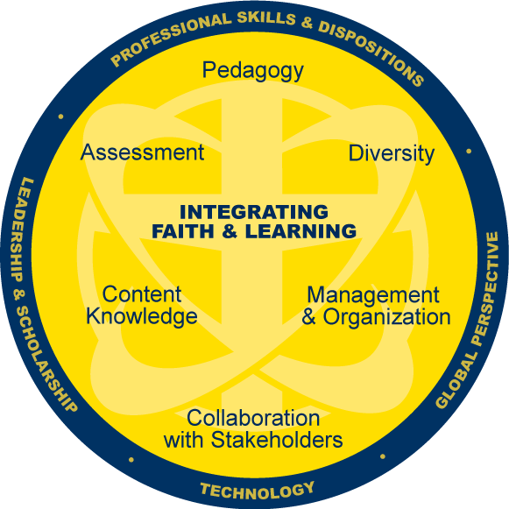
Check the appropriate statement:
_____ I recommend this candidate continue in the teacher education program at SAU.
_____ I recommend with reservation this candidate continue in the teacher education program at SAU.
_____ I do not recommend that this candidate continue in the teacher education program at SAU.
________________________________________________ _____________________
Mentor Teacher’s Signature Date

COMMENTS:

*********************************************************************************************************************************************
Check the appropriate statement:
_____ I recommend this candidate continue in the teacher education program at SAU.
_____ I recommend with reservation this candidate continue in the teacher education program at SAU.
_____ I do not recommend that this candidate continue in the teacher education program at SAU.

________________________________________________ _____________________
Professor’s Signature Date
COMMENTS:

******************************************************************************************
________________________________________________ _____________________
Candidate’s Signature Date
(Signature verifies awareness of information in this rating instrument and does not signify agreement or disagreement with the ratings.

