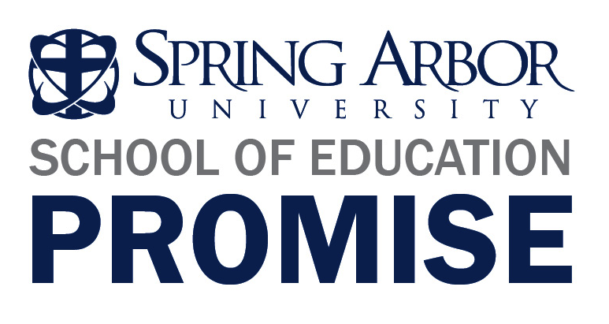

SAU’s School Of Education Develops Teacher Training Promise For Educators
In response to current Michigan legislation that requires all teachers in Michigan to participate in an annual evaluation program, Spring Arbor University’s School of Education has established the Spring Arbor University School of Education Promise, which will guarantee individualized mentoring and specific advanced teacher assistance for any SAU School of Education graduate.
The School of Education Promise will be applicable for all Spring Arbor University teacher preparation/certified graduates, beginning in Spring 2012 forward and within a five year window of employment, who are struggling in their professional practice as indicated by a less than effective rating on the annual evaluation. During the period of one academic year immediately following the evaluation, Spring Arbor University’s School of Education will provide individualized mentoring and assistance appropriate to the teacher’s specific needs, which can include up to nine educational credits at no tuition cost to the teacher. The Promise provides this opportunity for the period of one year following the initial performance evaluation, under which the claim is made. Certain restrictions apply. Visit arbor.edu/promise for additional information.
“Spring Arbor University strives to graduate highly-qualified educators who are successful in their own classrooms. We believe that our approach to teacher preparation provides the graduates of both our undergraduate and graduate programs with the solid footing needed to meet the changing expectations of the future. We are so confident of this that we have created the Spring Arbor University School of Education Promise,” says Linda Sherrill, School of Education dean.
The Michigan Department of Education has ranked Spring Arbor University’s education program among the top with an exemplary mark for teacher-prep programs each year it has evaluated colleges granting education degrees. The SOE Promise is just one example of how committed Spring Arbor University’s SOE is to helping its students succeed. And success is nothing new for our education graduates. Spring Arbor University’s School of Education has produced two Michigan student teachers of the year and five runners-up in the past seven years. Two alums were also awarded the Milken National Educator Award. This prestigious award is given to 100 teachers nationwide (two per state), and in 2004, both Michigan recipients were SAU graduates. For more information about the School of Education, visit: http://www.arbor.edu/academics/school-of-education/school-of-education-promise/ .

