Teacher Education Workroom Puppets

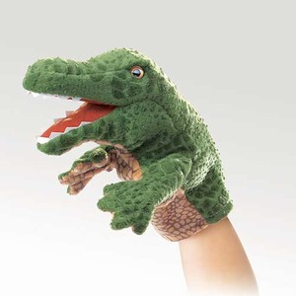
Alligator (Little) Hand Puppet

7 Inches Tall
Call Number – 791.53 LAL

Related Picture Books @ SAU

- Alligators All Around CL-P S474
- Black Jack: Last of the Big Alligators CL 598.14 M128
- About Reptiles: A Guide for Children CL 597.9 S584

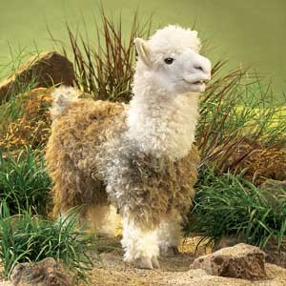
Alpaca Hand Puppet

17 Inches Tall
Moveable Mouth
Call Number – 791.53 ALP

Related Picture Books @ SAU

- Llama Llama I love You CL-P D515
- Llama Llama Trick or Treat CL-P D515

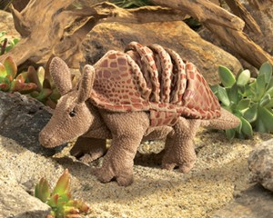
Armadillo Hand Puppet

5 Inches Tall
Moveable Mouth & Legs
Rolls into a ball with Velcro fasteners
Call Number – 791.53 ARM

Related Picture Books @ SAU

- Armadillo Rodeo CL-P B845

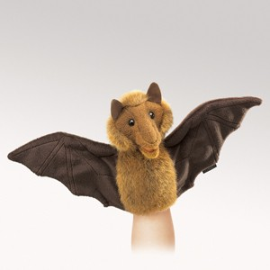
Bat (Little) Hand Puppet

15 Inches Wide
Moveable Mouth and Wings
Call Number – 791.53 LBT

Related Picture Books @ SAU

- Little Lost Bat CL-P M346
- The Bat-Poet CL-F J37
- Stellaluna CL-P C226

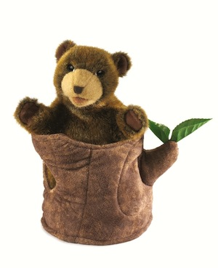
Bear in Tree Hand Puppet

10 Inches Tall
Movable Mouth and Front Paws
Bear Can Hide In Stump
Call Number – 791.53 BTS

Related Picture Books @ SAU
- Two Bear Cubs CL-P J76
- We Are Bears CL-P G876
- Old Bear CL-P H513
- Can’t You Sleep Little Bear? CL-P W116
- Un Beso de Buenas Noches CL-P H588

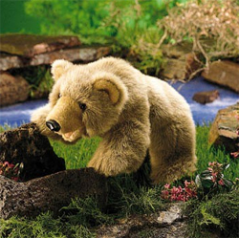
Bear (Grizzly Bear Cub) Hand Puppet

17 Inches Long
Workable Mouth
Call Number – 791.53 GRI

Related Picture Books @ SAU
- Old Bear CL-P H513
- Goodnight Bear CL-P B879
- The Legend of Sleeping Bear CL-P W274
- Bear Shadow CL-P A812
- The Grizzly CL-F J66
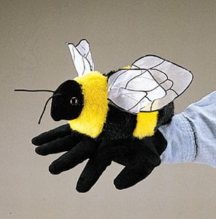
Bee Hand Puppet

8 Inches Long
Moveable Legs
Call Number – 791.53 BEE

Related Picture Books @ SAU

- The Bee Tree CL-P P762
- The Hive Detectives CL 638.13 B967
- Bees and Honey CL 595.799 B415
- No Holidays for Honeybees CL 595.799 K21

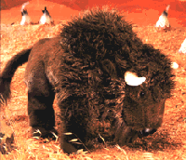
Bison Hand Puppet

15 Inches Long
Movable Mouth and Front Legs
Call Number – 791.53 BIS

Related Picture Books @ SAU
- The Great Plains CL-P M172
- Follow The Trail CL-P T374

Butterfly Hand Puppet
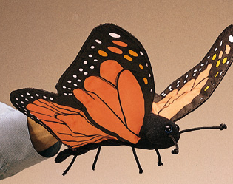
14 Inch Wing Span
Call Number – 791.53 BUT

Related Picture Books @ SAU
- An Extraordinary Life CL 595.789 P957
- To Ride a Butterfly CL 810.8 T627
- The Butterfly CL-P P762
- Butterfly time CL 595.7 G688

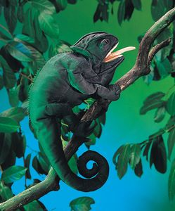
Chameleon Hand Puppet

18 Inches Long
Moveable Mouth, Tongue, and Eyes
Call Number – 791.53 CHA

Related Picture Books @ SAU

- Coming Soon!

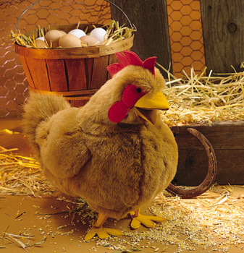
Chicken (Red Hen) Hand Puppet

23 Inches Long
Workable Mouth
Call Number – 791.53 RED

Related Picture Books @ SAU
- Crabby Cratchitt CL-P M213
- Across the Stream CL-P G493
- The Silly Chicken CL-P S525
- Three Hens and a Peacock CL-P L231

Chipmunk (Little) Hand Puppet
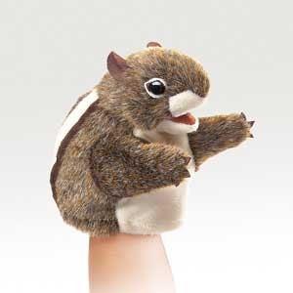
6 Inches Tall
Moveable Mouth and Paws
Call Number – 791.53 LCH

Related Picture Books @ SAU

- Chipmunk Stew CL-P L767

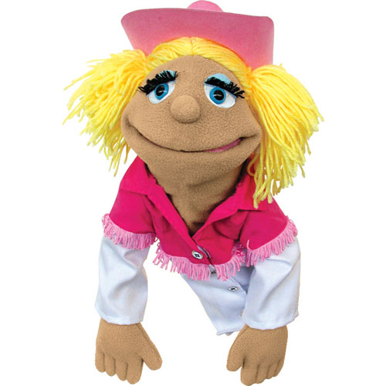
Cowgirl Puppet

15 Inches Tall
Movable Mouth
Stick Connected to Hand
Call Number – 791.53 COW

Related Picture Books @ SAU
- Why Cowgirls are Such Sweet Talkers CL-P K73
- The Finest Horse in Town CL-P M381

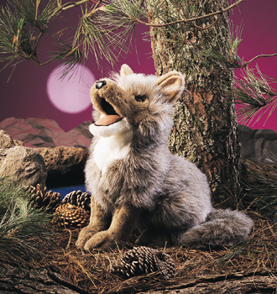
Coyote Hand Puppet

16 Inches Long
Workable Mouth
Call Number – 791.53 COY

Related Picture Books @ SAU
- Coyote and the Laughing Butterflies CL-P T242
- Theatre for Young Audiences CL 812.008 T374
- Coyote Places the Stars CL-P T242
- Dream Wolf CL-P G575

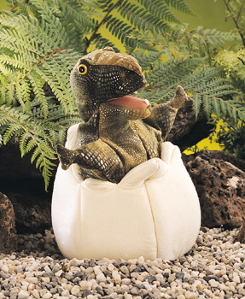
Dinosaur Egg Hand Puppet

10 Inches Tall
Workable Mouth
Call Number – 791.53 DIN

Related Picture Books @ SAU
- Dinosaur Story CL 568.19 C689
- Dinosaur ABC’s CL 568.19 M152
- Dinosaur Dances CL 811.54 Y54
- Home for a Dinosaur CL 372.4 TRO Big Book

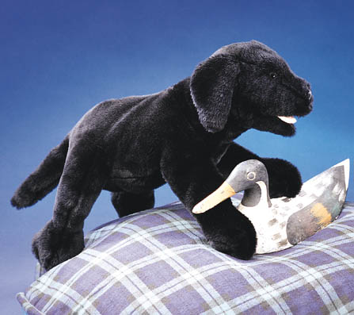
Dog (Black Labrador) Hand Puppet

20 Inches Long
Workable Mouth
Call Number – 791.53 BLA

Related Picture Books @ SAU
- No Puppies Today! CL-P C689
- A Puppy is Born CL-P F529
- Dog CL 599.772 C649
- The Other Dog CL-P L566
- Clifford, the Big Red Dog CL-P B852

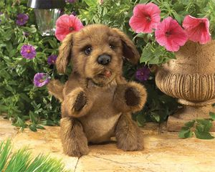
Dog (Brown Puppy) Hand Puppet

10 Inches Tall
Moveable Mouth and Front Paws
Call Number – 791.53 BRO

Related Picture Books @ SAU

- The Other Dog CL-P L566
- Dog CL 599.772 C649
- Clifford, the Big Red Dog CL-P B852
- No Puppies Today! CL-P C689
- A Puppy is Born CL-P F529
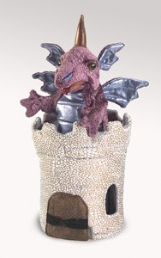
Dragon in Turret

14 Inches Tall
Pop-up with moveable Mouth and Arms
Call Number – 791.53 DTU

Related Picture Books @ SAU

- The Dragon of Doom CL-F C873
- Eric Carle’s Dragons CL 808.81 C278
- Dragon’s Egg CL-F T485
- Dragonsdale CL-F D763
- The Loathsome Dragon CL-P W651

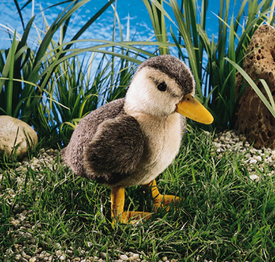
Duck (Mallard Duckling) Hand Puppet

10 Inches Tall
Call Number – 791.53 MAL

Related Picture Books @ SAU
- The Tale of Jemima Puddle Duck CL-P P866
- The Chick and the Duckling CL-P S965
- Across the Stream CL-P G493
- The Story About Ping CL-P F571
- Click, Clack, Quackity-Quack CL-P C947

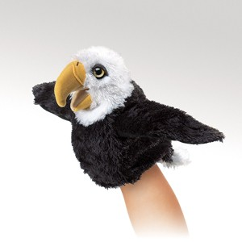
Eagle (Little) Hand Puppet

8 Inches Tall
Moveable Mouth and Wings
Call Number – 791.53 LEA

Related Picture Books @ SAU

- Aesop’s Fables CL 398.24 S237

Elephant Hand Puppet
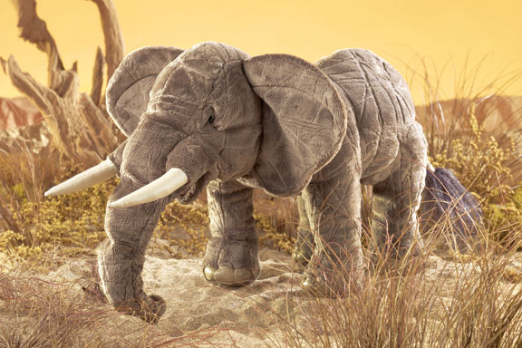
20 Inches Long
Moveable Mouth
Pull Strings to Curl and Uncurl the Trunk
Call Number – 791.53 ELE

Related Picture Books @ SAU

- The Saggy Baggy Elephant CL-P T461
- The Ant and the Elephant CL-P P375
- Baby Elephant and the Secret Wishes CL-F J83
- The Story of Babar, the Little Elephant CL-P B895
- Desert Elephants CL 599.67 C874
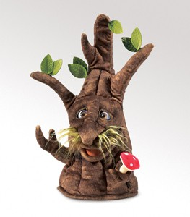
Enchanted Tree Hand Puppet

15 Inches Tall
Moveable Mouth, Branches, & Eyes
Call Number – 791.53 ENC

Related Picture Books @ SAU

- Coming Soon!

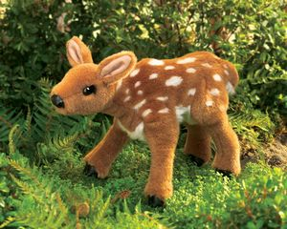
Fawn Hand Puppet

13 Inches Long
Movable Head and Front Legs
Call Number – 791.53 FAW

Related Picture Books @ SAU
- The Yearling CL-F R259
- Bambi: A Life in the Woods CL-P S176
- First Snow in the Woods CL-P S193
- Stranger in the Woods CL-P S193
- Wonders of the Woodland Animals CL 591.5 B533

Flying Dragon Hand Puppet
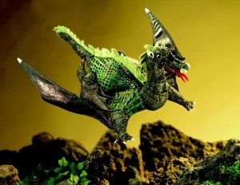
25 Inches Wide
Movable Head and Arms
Call Number – 791.53 DRA

Related Picture Books @ SAU
- The Dragon of Doom CL-F C873
- Eric Carle’s Dragons CL 808.81 C278
- Dragon’s Egg CL-F T485
- Dragonsdale CL-F D763

Fox (Red Fox) Hand Puppet
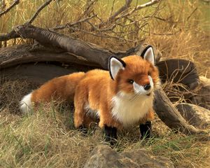
18 Inches Long
Movable Mouth
Call Number – 791.53 FOX

Related Picture Books @ SAU
- Fox and His Friends CL-P M367
- Flossie and the Fox CL-P M158
- One Fine Day CL-P H716
- Saving Samantha: A True Story CL-P F829

Goose Hand Puppet
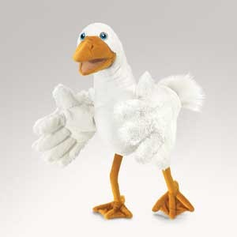
16 Inches Long
Two-Hand Puppet
Moveable Wings and Beak
Call Number – 791.53 GOO

Related Picture Books @ SAU

- The Goose Girl CL-F H164
- Goose CL-P B216
- My Very First Mother Goose CL-P M995
- Petunia CL-P D987

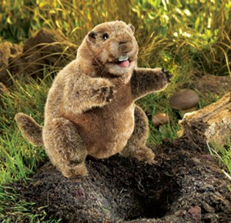
Groundhog Hand Puppet

10 Inches Tall
Moveable Mouth and Forelegs
Call Number – 791.53 GRO

Related Picture Books @ SAU

- Gregory’s Shadow CL-P F855

Hedgehog Hand Puppet
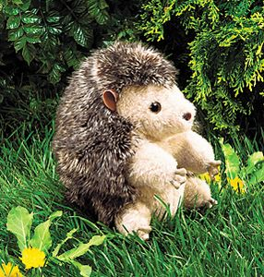
7 Inches Tall
Moveable Head, Arms, & Legs
Turns Inside Out and Curls into a Ball
Call Number – 791.53 HED

Related Picture Books @ SAU

- Porcupining: A Prickly Love Story CL-P W563
- Hedgie’s Surprise CL-P B845
- The Hat CL-P B845
- The Tale of Mrs. Tiggy-Winkle CL-P P866

Horse Hand Puppet

17 Inches Tall
Moveable Mouth
Call Number – 791.53 HRS

Related Picture Books @ SAU

- The Finest Horse in Town CL-P M381
- A Girl Called Bob & a Horse Called Yoki CL-F C187
- The Horse in Harry’s Room CL-P H698
- Justin Morgan Had a Horse CL-F H523

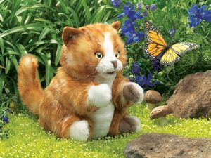
Kitten (Orange Kitten) Hand Puppet

8 Inches Tall
Moveable Mouth, Arms, and Legs
Call Number – 791.53 ORA

Related Picture Books @ SAU
- Allison CL-P S274
- My Cats Nick and Nora CL-P H294
- Millions of Cats CL-P G132
- Kitten’s First Full Moon CL-P H513
- Mrs. Katz and Tush CL-P P762
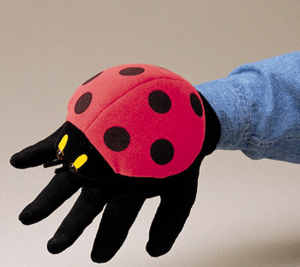
Ladybug Hand Puppet

9 Inches Long
Glove Puppet
Call Number – 791.53 LAD

Related Picture Books @ SAU
- Ladybug CL 595.769 M128
- The Bug Book CL 595.7 B931
- Billions of Bugs CL 595.7 P487
- Quick as a Wink CL 595.7 A363

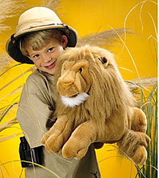
Lion Hand Puppet

19 Inches Long
Workable Mouth
Call Number – 791.53 LIO

Related Picture Books @ SAU
- Library Lion CL-P K74
- The Lion and the Mouse CL-P P655
- The Lion, Witch and the Wardrobe CL-F L673
- The Lion and the Rat CL-P L166
- Andy and the Lion CL-P D238

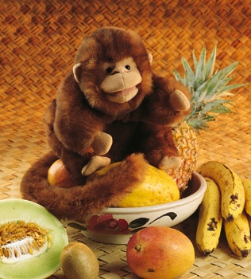
Monkey Hand Puppet

10 Inches Tall
Workable Mouth
Call Number – 791.53 MON

Related Picture Books @ SAU
- The Monkey and the Crocodile CL-P G149
- Caps for Sale CL-P S634
- Curious George Goes to the Hospital CL-P R456
- Ape in a Cape: Alphabet of Odd Animals CL 636.8 E34

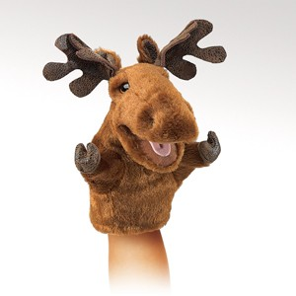
Moose (Little) Hand Puppet

8 Inches Tall
Moveable Mouth and Forelegs
Call Number – 791.53 LMO

Related Picture Books @ SAU

- A Chocolate Moose for Dinner CL-P G995
- A Moose for Jessica CL 599.73 W147
- Looking for a Moose CL-P R783

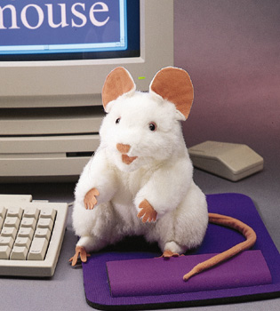
Mouse (White Mouse) Hand Puppet

8 Inches Tall
Workable Mouth
Call Number – 791.53 WHI

Related Picture Books @ SAU
- The Lion and the Mouse CL-P P655
- Whose Mouse Are You? CL-P K91
- Mouse Soup CL-P L797
- Mitt, the Michigan Mouse CL-P K91
- If You Give a Mouse a Cookie CL-P N971

Octopus (Red Octopus) Hand Puppet
19 Inches Long
Glove Puppet
Call Number – 791.55 OCT

Related Picture Books @ SAU

- Cowboy & Octopus CL-P S416
- The Phantom World of Octopus
and Squid CL 594.56 C771
- Marvels of Creation: Sensational
Sea Creatures CL 591.77 D261

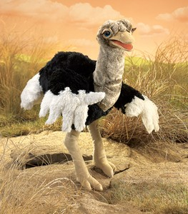
Ostrich Hand Puppet

23 Inches Tall
Moveable Head, Neck, & Mouth
Two-handed Wing movement
Call Number – 791.53 OST

Related Picture Books @ SAU

- Coming Soon!

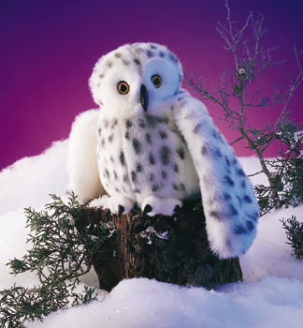
Owl (Snowy Owl) Hand Puppet

21 Inch Wingspan
Head Turns 360 Degrees
Call Number – 791.53 SNO

Related Picture Books @ SAU
- Owl Moon CL-P Y54
- Owls in the Family CL-F M936
- Good-Night Owl CL 372.6 ALA Big Book
- Le hibou et la poussiquette CL-P L438

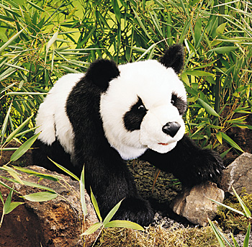
Panda Hand Puppet

23 Inches Long
Workable Mouth
Call Number – 791.53 PAN

Related Picture Books @ SAU
- Oso Panda, Oso Panda, Qu Ves Ah? CL-P 379
- Little Panda CL-P R992
- Two Bear Cubs CL-P J76
- The Bear and the Fly: a story CL-P W786

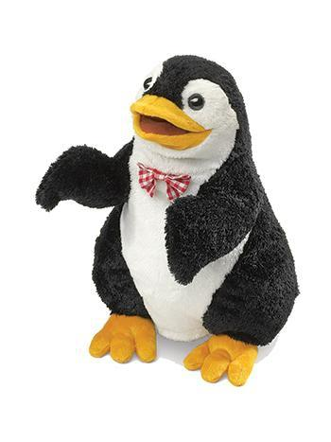
Penguin (Bow Tie) Hand Puppet

12 Inches Tall
Workable Mouth and Flippers
Call Number – 791.53 PEN

Related Picture Books @ SAU
- Penguins CL 598.47 G411
- Mr. Popper’s Penguins CL-F A887
- Sergio Makes a Splash CL-P R696
- Tacky the Penguin CL-P L642
- Emperor Penguins CL 598.47 E26
- The Penguin CL 598.441 D148

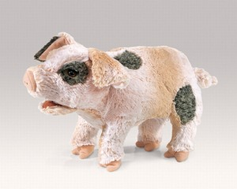
Pig (Grunting) Hand Puppet

14 Inches Long
Workable Snout, Mouth, & Front Trotters
Realistic Grunting Sound
Call Number – 791.53 PIG

Related Picture Books @ SAU
- Pig’s Ahoy! CL-P M172
- The Three Little Pigs CL-P T374
- Pigs from 1 to 10 CL-P G313
- The Fourth Little Pig CL-P C394
- Pig Tale CL-P O98

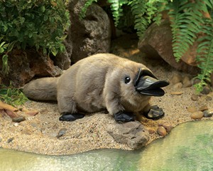
Platypus (Baby) Hand Puppet

16 Inches Long
Moveable Mouth and Forelegs
Call Number – 791.53 PLA

Related Picture Books @ SAU

- Coming Soon!

Policeman Puppet

8 Inches Tall
Movable Mouth
Stick Connected to Hand
Call Number – 791.53 POL

Related Picture Books @ SAU
- Mike’s House CL-P S255
- The Year We Disappeared CL-P B976
- Officer Bucket and Gloria CL-P R234
- The True Book of CL 351.74 M664
Policemen and Firemen

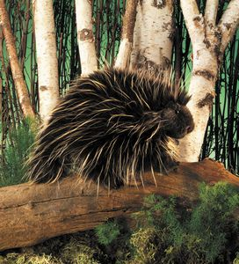
Porcupine Hand Puppet

7 Inches Tall
Moveable Head, Arms, & Feet
Call Number – 791.53 POR

Related Picture Books @ SAU

- Porcupining: a Prickly Love Story CL-P W563
- All on a Mountain Day CL-F F533
- Pins & Needles CL-P K92

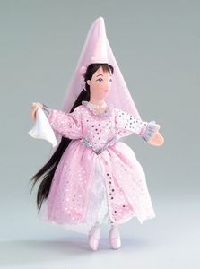
Princess Hand Puppet

14 Inches Tall
Call Number – 791.53 PRS

Related Picture Books @ SAU

- The Princess Knight CL-P F982
- The Princess and the Goblin CL-F M135
- Princess Furball CL 398.2 H882
- The Goose Girl CL-F H164

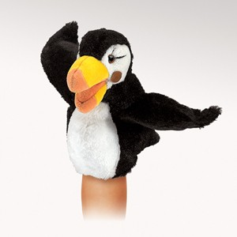
Puffin (Little) Hand Puppet

8 Inches Tall
Moveable Beak and Wings
Call Number – 791.53 LPU

Related Picture Books @ SAU

- There Once Was a Puffin CL-P J36
- Nights of the Pufflings CL-P M167

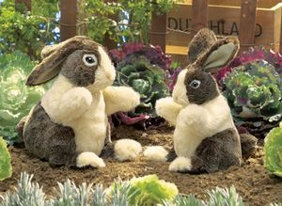
Rabbit (Dutch) Hand Puppet

10 Inches Tall
Moveable Head and Arms
Call Number – 791.53 DUT

Related Picture Books @ SAU
- The Tale of Peter Rabbit CL-P P866
- Foolish Rabbit’s Big Mistake CL-P M382
- Benjamin’s Treasure CL-P W723
- The Bunny Who Found Easter CL-P Z86
- My Friend Rabbit CL-P R738

Raccoon Hand Puppet
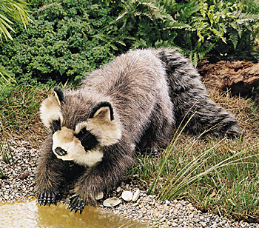
23 Inches Long
Workable Mouth
Call Number – 791.53 RAC

Related Picture Books @ SAU
- Aise-ce-bon, a Raccoon CL 599.7 B812
- Little Rascal CL-F N867
- Junie B. Jones Smells Something Fishy CL-F P235
- Rascal CL-B N867

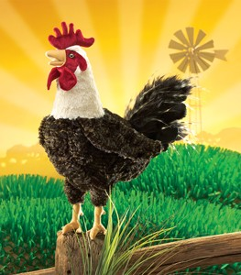
Rooster Hand Puppet
17 Inches Tall
Moveable Head and Beak
Call Number – 791.53 ROO

Related Picture Books @ SAU

- Cock-a-doodle Dudley CL-P P375
- Rooster’s Off to See the World CL-P C278
- Chanticleer and the Fox CL 821 C496
- The Bremen-town Musicians CL-P G878

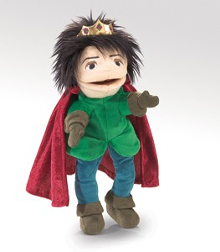
Royal Prince Hand Puppet

11 Inches Tall
Moveable Mouth and Arms
Call Number – 791.53 PRI

Related Picture Books @ SAU

- The Little Prince CL-F S137

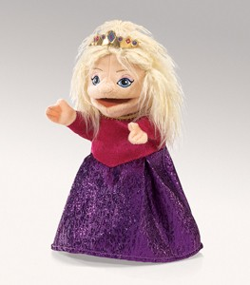
Royal Princess Hand Puppet

11 Inches Tall
Moveable Mouth and Arms
Call Number – 791.53 ROY

Related Picture Books @ SAU

- The Princess Knight CL-P F982
- The Princess and the Goblin CL-F M135
- The Goose Girl CL-F H164
- Princess Furball CL 398.2 H882
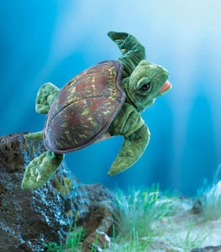
Sea Turtle Hand Puppet

16 Inches Long
Moveable Mouth and Front Flippers
Call Number – 791.53 SEA

Related Picture Books @ SAU

- Yertle the Turtle and Other Stories CL-P S496
- Look, There is a Turtle Flying CL 398.2 D666

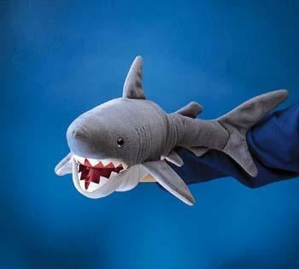
Shark Hand Puppet

22 Inches Long
Workable Mouth
Call Number – 791.53 SHA

Related Picture Books @ SAU
- I am a Shark CL-P S857
- Dolphins and Sharks CL 599.53 O81
- Don’t Eat The Teacher! CL-P W261
- Sharks CL 597.31 S596
- The Story of Three Kingdoms CL-P M996

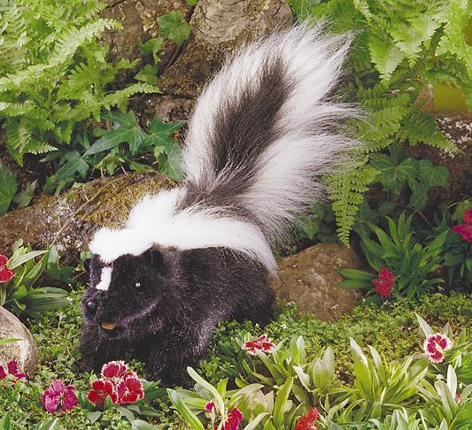
Skunk Hand Puppet

15 Inches Long
Workable Mouth
Call Number – 791.53 SKU

Related Picture Books @ SAU
- What’s Wrong with Being a Skunk? CL 599.74 S341
- A Kiss For a Little Bear CL-P M663
- The Biology of the Striped Skunk CL 599.744 V568
- The Barn CL-P S365

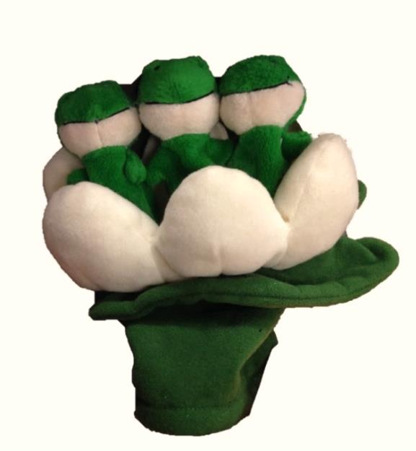
Tadpoles Froggles Family

Three Moveable Tadpoles
Call Number – 791.53 TAD

Related Picture Books @ SAU

- The Mysterious Tadpole CL-P K29
- Frog Went A-Courtin’ CL-P L285
- Days with Frog and Toad CL-P L797
- Frog and Toad All Year CL-P L797
- Frog and Toad Together CL-P L797
- Frog and Toad Are Friends CL-P L797

Tarantula Hand Puppet
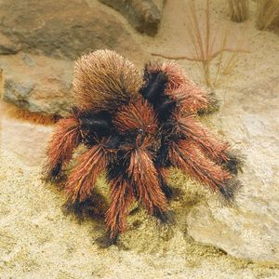
9 Inches Long
Two Moveable Legs
Call Number – 791.53 TAR

Related Picture Books @ SAU

- The Tarantula Scientist CL 595.44 M788
- Not-so-normal Norman CL-F S892
- Diary of a Spider CL-P C947
- The Spider and the Fly CL-P H863

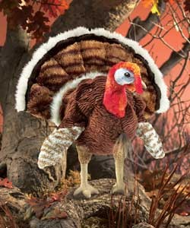
Turkey Hand Puppet

13 Inches Wide
Call Number – 791.53 TUR

Related Picture Books @ SAU

- Coming Soon!

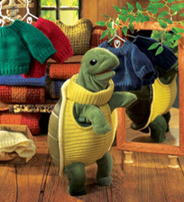
Turtleneck Turtle Hand Puppet

12 Inches Tall
Workable Mouth and Front Legs
Call Number – 791.53 TUR

Related Picture Books @ SAU
- The Legend of Mackinac Island CL 398.2 W274
- Yertle the Turtle CL-P S496

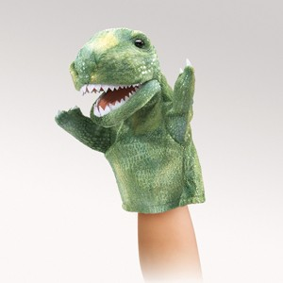
Tyrannosaurus Rex (Little) Hand Puppet

6 Inches Tall
Moveable Mouth and Arms
Call Number – 791.53 LTY

Related Picture Books @ SAU

- Barnum’s Bones CL-B B877
- Dinosaur’s Unleashed CL 231.765 B988
- How do Dinosaurs Say Good Night? CL-P Y54
- Edwina, the Dinosaur Who CL-P W699
Didn’t Know She Was Extinct

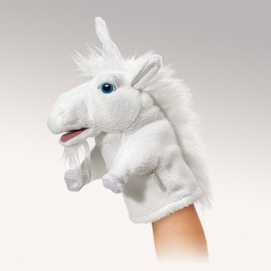
Unicorn (Little) Hand Puppet

8 Inches Tall
Moveable Mouth and Front Legs
Call Number – 791.53 LUN

Related Picture Books @ SAU

- Unicorns! Unicorns! CL-P M123
- Behold—the Unicorns! CL 398.2454 G441

Whale Hand Puppet
13 Inches Long
Moveable Mouth
Call Number – 791.53 WHA

Related Picture Books @ SAU

- Marvels of Creation CL 591.77 D261
- Sea Squares CL-P H915

